**BOTO3 is a python library which connects aws using python**

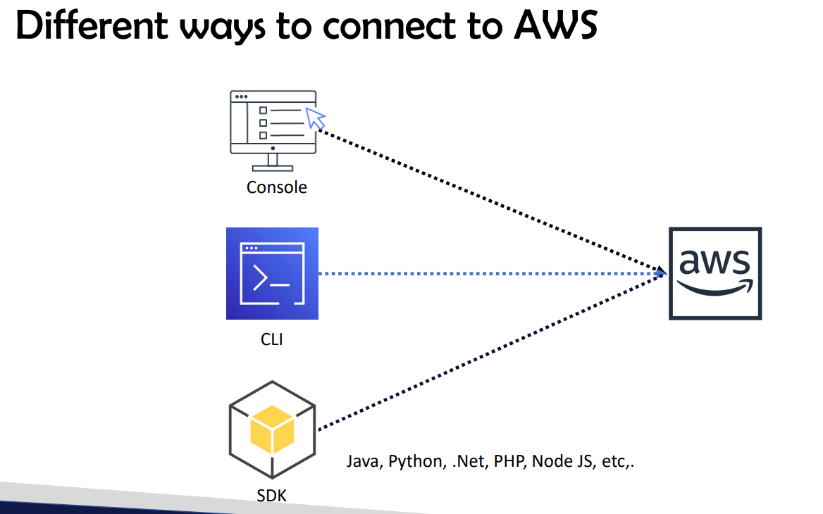

**For devops engineer aws console and aws cli will be enough**

* **If you want to become developer you need to have knowledge on aws sdk as they use sdk for automations**
* **Http apis also you can perform operations**
* **For infrastructure automation will use cloud formation**
* **95% you can use console for aws services work rest sdk ,cli,api’s you can use 100% for aws services**
* **For creating and modifying aws infrastructure will use terraform and cloud formation but for read purpose and any other purpose it wont be useful**
* **For management you will be using console, sdk ,cli, Http APi’s**

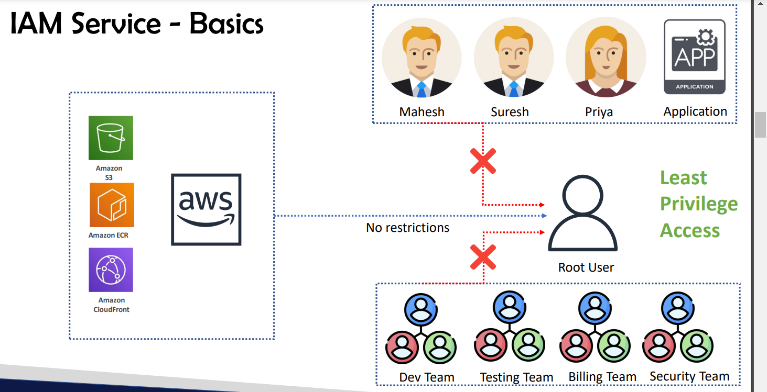

**IAM : Identity and access management**

* **We need to give least privilege access to the users**
* **That’s the best practice for the aws security**
* **AS root user has all the access**

**CRUD -Create read update delete permissions**

* **So You can give access according to the employee designation**
* **So you can give access for particular services as well according to project requirement**

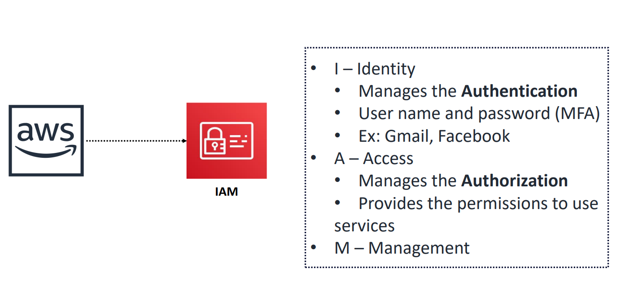

**Identity:** identity is for only authentication i.e, user name and password verification

**Access : Manges the Authorization i.e, giving permissions for the users for particular services like Read write permissions**

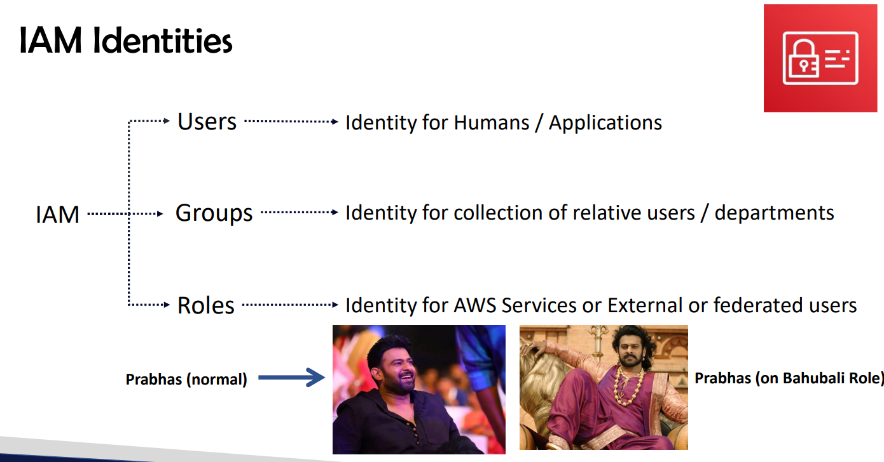

**Users: for humans/applications humans: user name & pwd applications: access keys**

**Groups: to keep users in in that particular departments**

* **Dev groups users belongs to developer background wil be pushed in to this group**

**To manage permissions in groups will be easier**

* **Role :when you assume role you will get all the permissions of roles and existing permission will be waived off and when you come out of roles you will get normal permissions**
* **Role is temporary credentials or temporary permissions**
* **For one service to another service connectivitiy we use roles(within the connectivity between services)**
* **Ex: EC2 S3 (Giving role to EC2 I.e to upload and download files from S3)**
* **For federated users that means people who are working on on premise they will be added to groups directly And they will be assigning to roles ex:1000 ppl are added to 50 groups and each group will be assigning one role**
* **Only if you are part of users then only you can go and check whether you are having permission to roles are not**
* **Roles is temporary access**
* **Users cannot be assigned to multiple roles at a time they will be assigned to single role at a time**

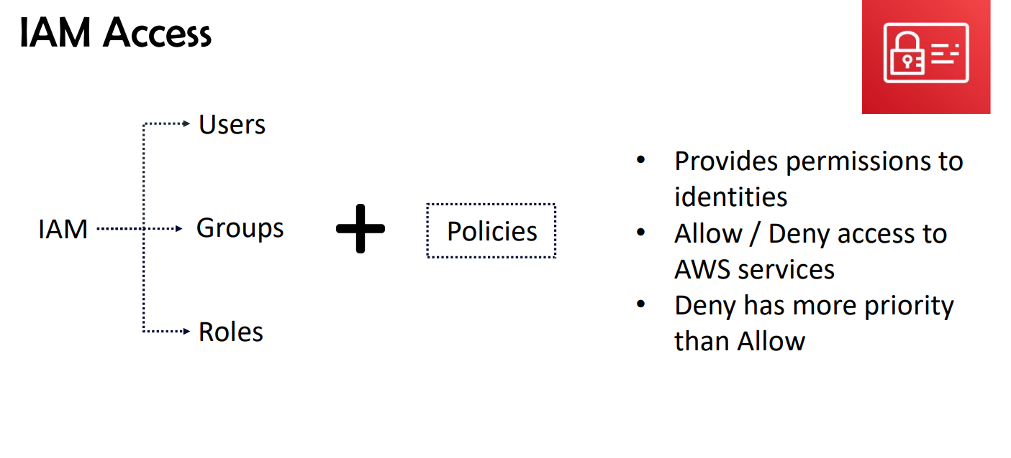

* **For identities you wont be getting permissions until and unless you attach policies**

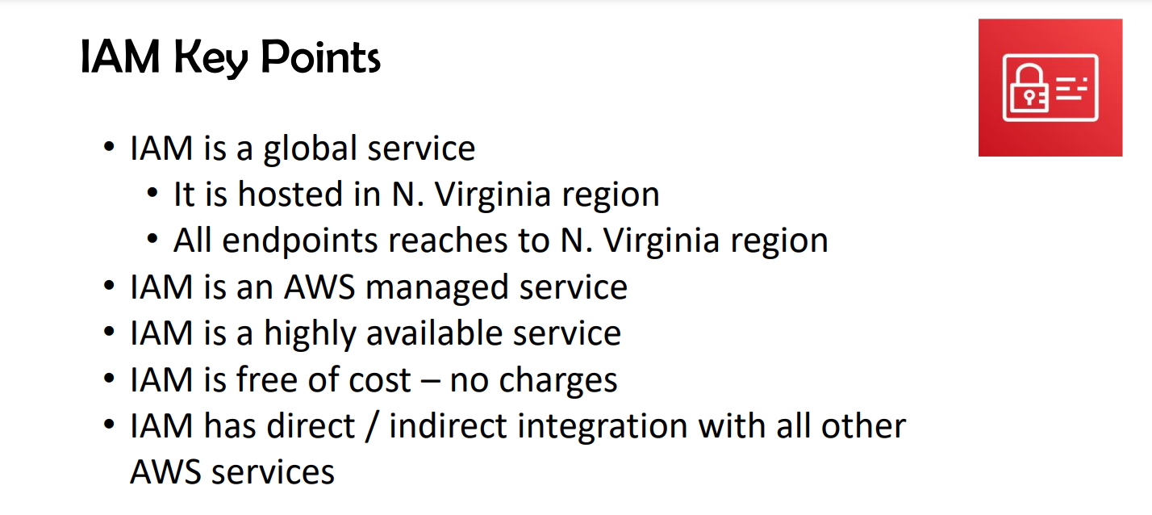

* **Services are of two types**

1. **Regional service**
2. **Global service**

* **Iam is a global service**
* **Gloabal services are hosted in north virginia**

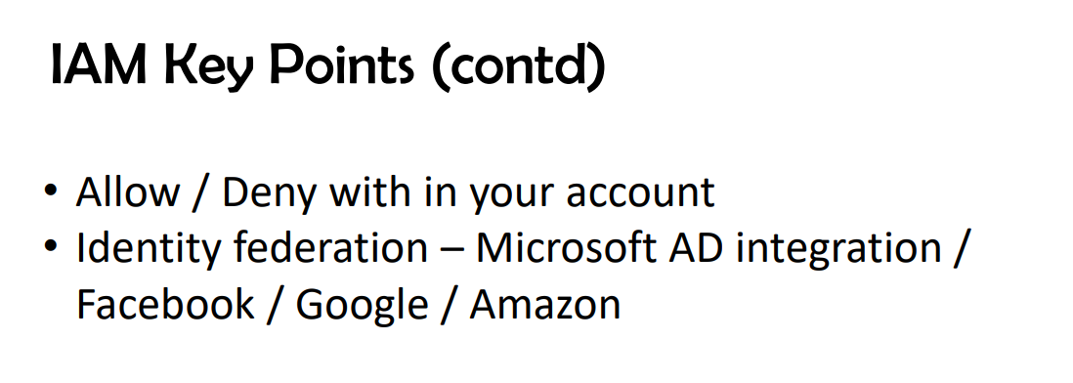

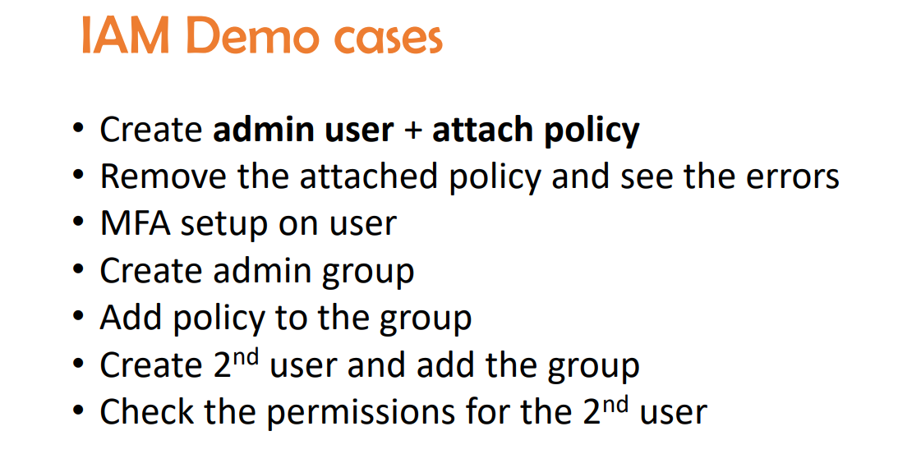

**For 1 user max 10 policies we can attach**

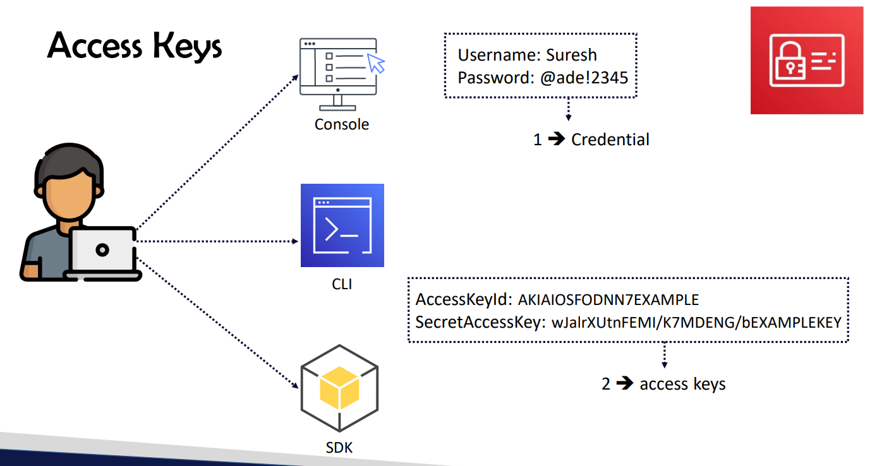

**You can generate 2 secrect access for one user**

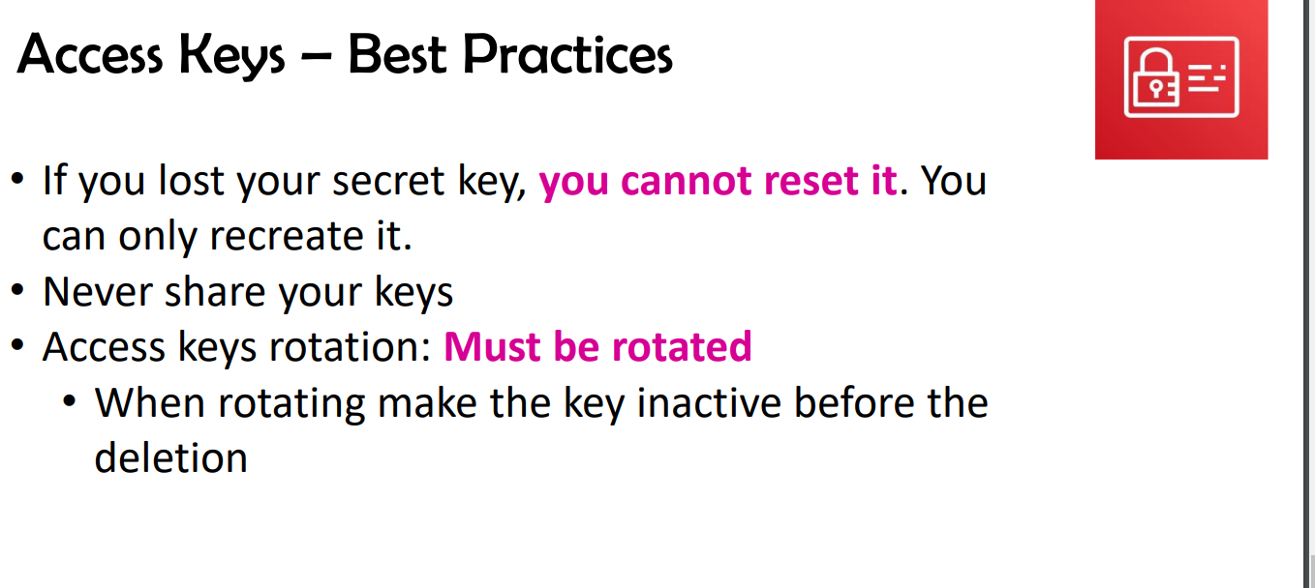

**If you lost the secret access you cannot retrieve you need to create 1 more access keys**

* **If you have 1 secret access for one access key you can generate one more secret access for the same access key**
* **As 2 secrest access is maximum number which we can create for one user**
* **For best practice access key should be changed for every three months first inactive the previous key**

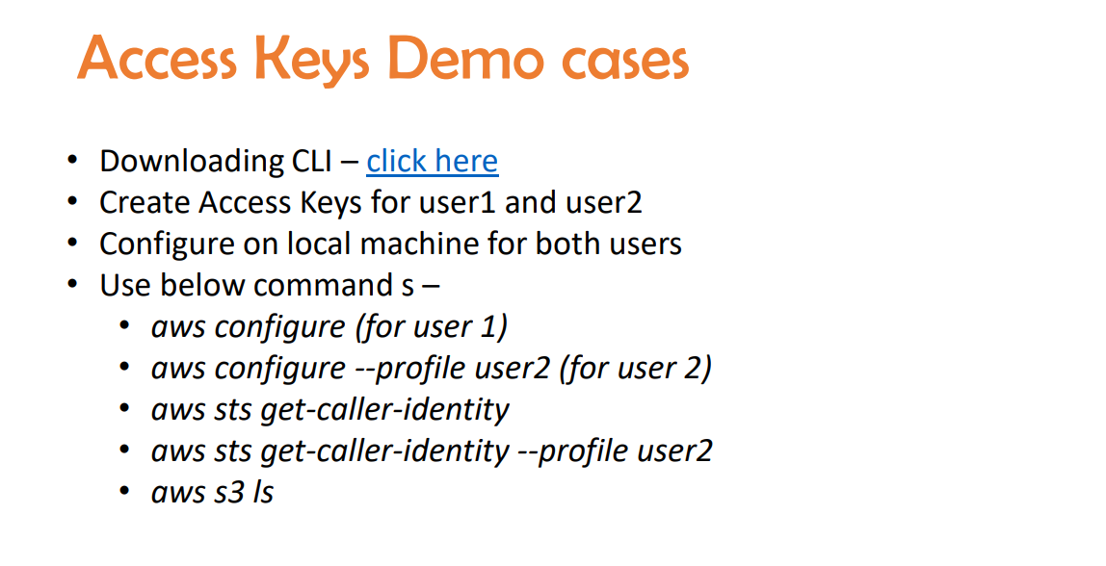

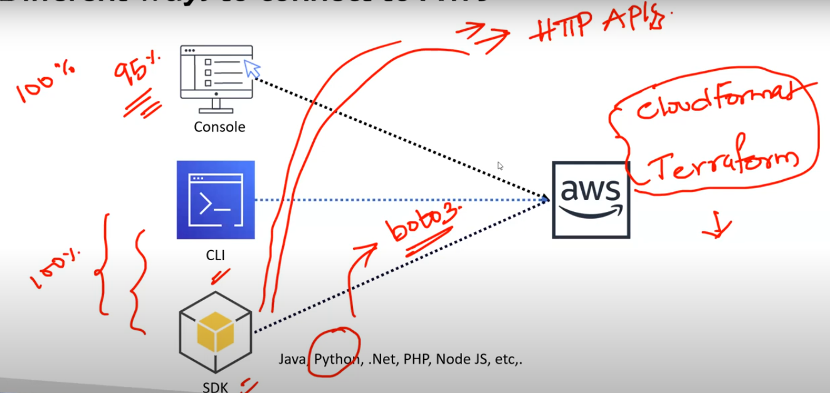

Cloud formation and terraform are only used to create and modify the infrastructure

Commands in cli

AWS iam list-users

In cli credententils are getting stored in credentials section

To know from which act we are logged in type command aws sts-get-caller-identity

Commands

aws configure

aws configure --profile user1

aws sts get-caller-identity

aws sts get-caller-identity --profile user2

aws s3 ls

aws iam list-users

AWS managed policies : AWS managed policies are the policies which are managed by aws

Customer managed polices : customer managed policies are the policies which are managed my Customer

Aws inline policy : AWS inline police is the policies which are only created for particular user and its not visible in policies section and visible only under user permissions tab.

169.254.169.254 even its windows machine or linux machine you will get meta data of that particular server on this ip address

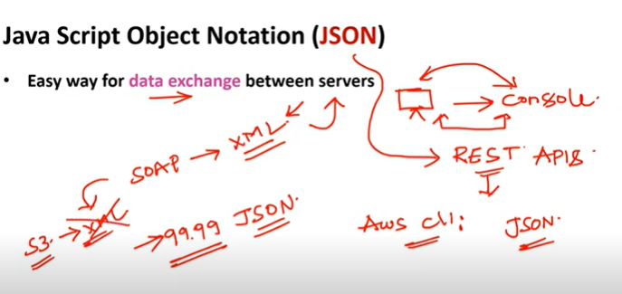

Json is used for data exchange between servers

For ex: from your laptop you are connecting to console

Between rest apis (use json)

* SCP(service control policies (to manage 4,5 accounts)

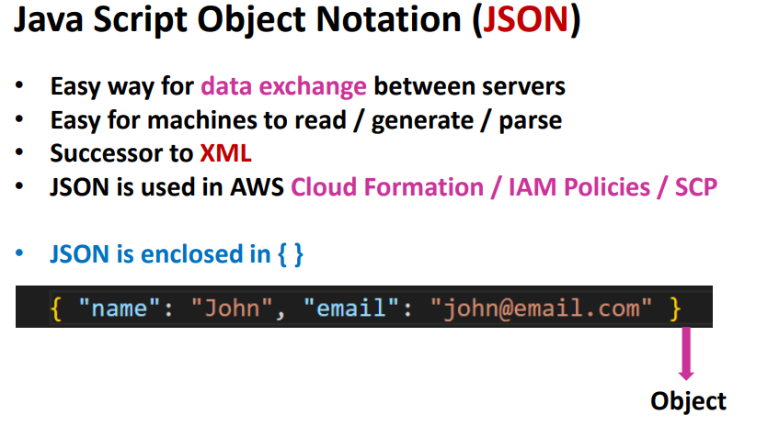

Json is enclosed in { } in python we call it as dictionary

Json formatter

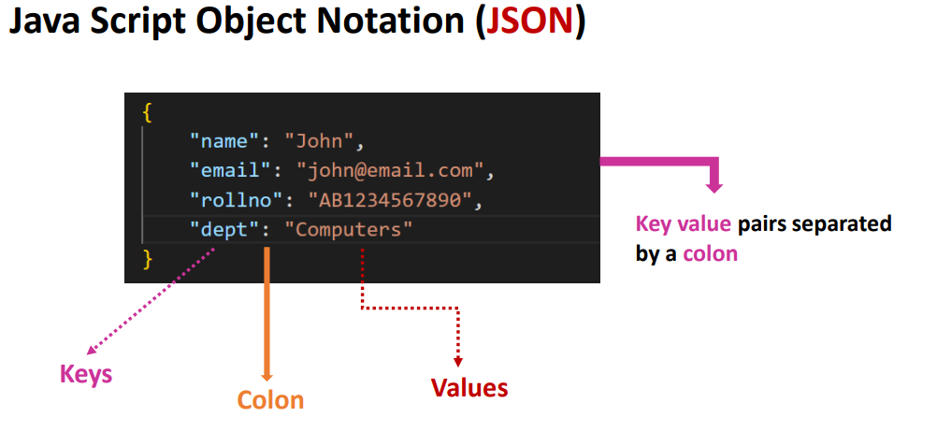

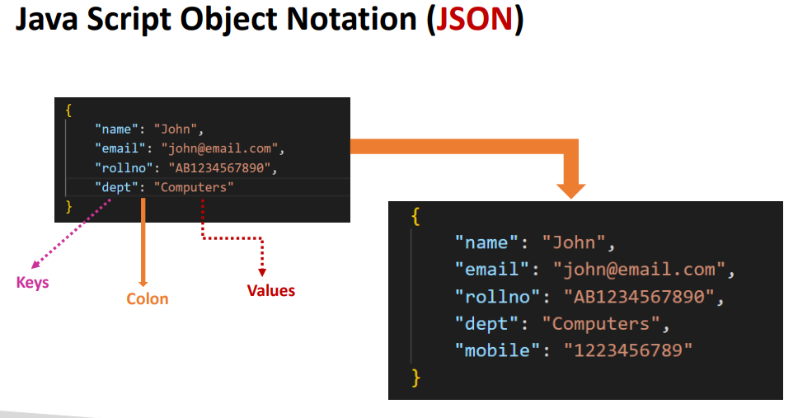

* Json keys left side would be string “ “

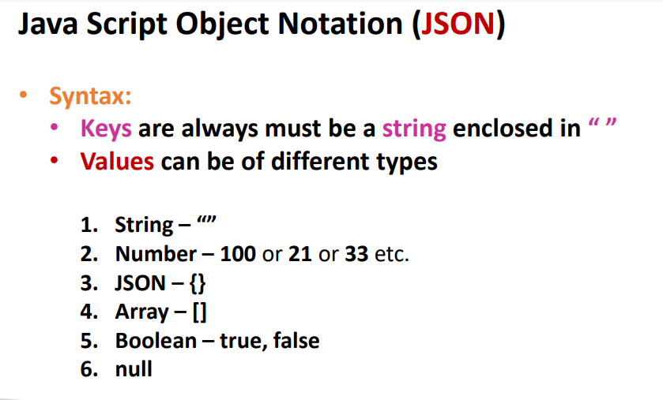

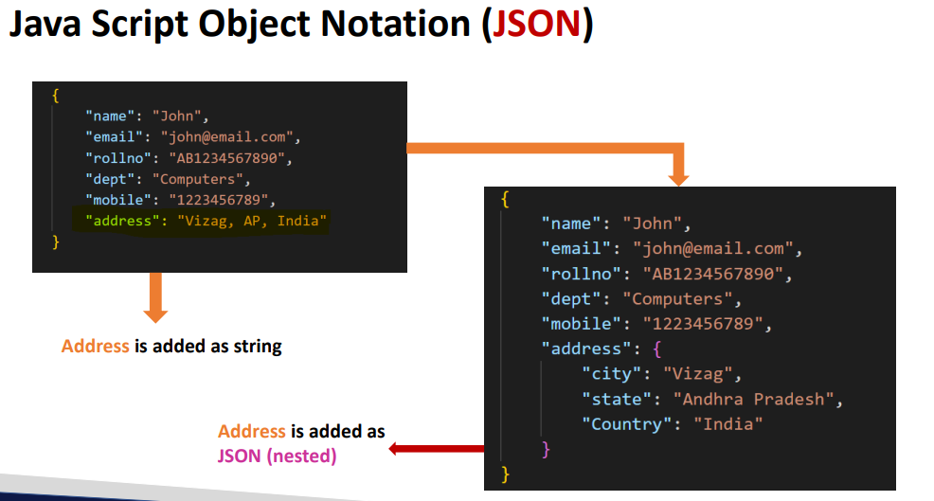

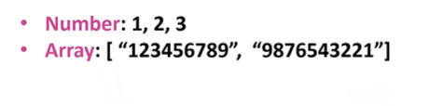

Array is used for similar types

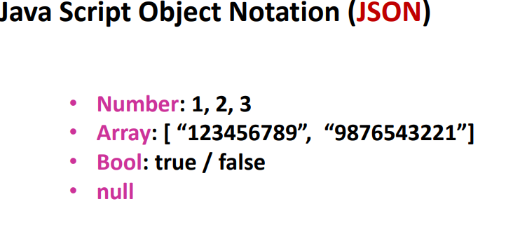

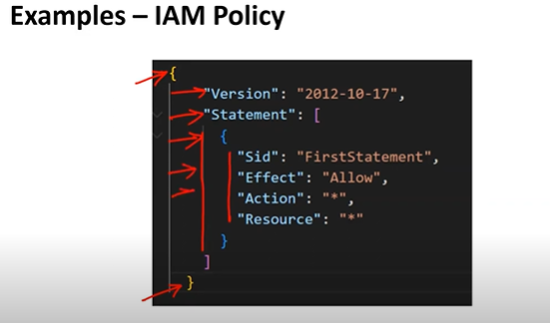

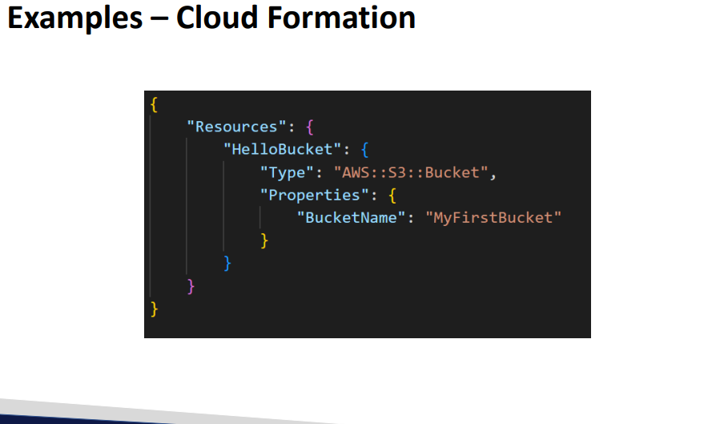

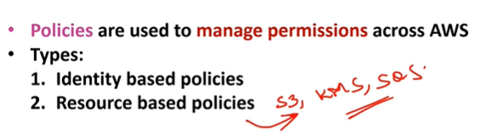

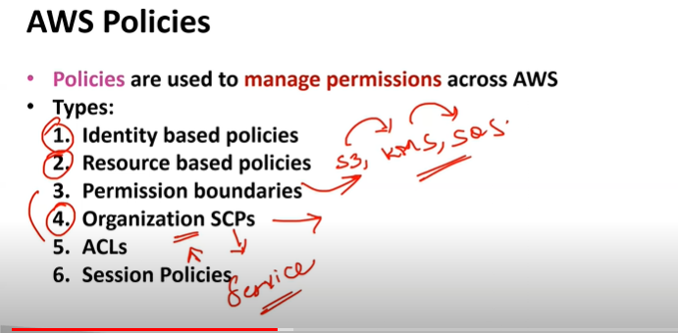

Identity based policies: are the policies of Iam like users groups roles

Resource based policy: the permissions which you give for services like public access to s3 is a resource based policy

* Resource based policy will not be there for all services only for few services it will be applicable ex: S3,SQS,KMS

LINK:

https://docs.aws.amazon.com/IAM/latest/UserGuide/access_policies.htmL

Organization scp’s to manage 4,5 accounts from one place we add those accounts to organization and for permission we use Service control policies

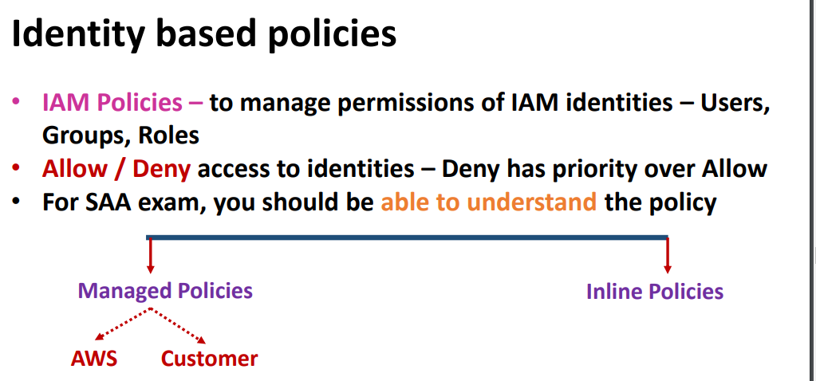

For all the services you will have full access and read access

Deny has more priority than allow

Link: <https://docs.aws.amazon.com/IAM/latest/UserGuide/access_policies.html>

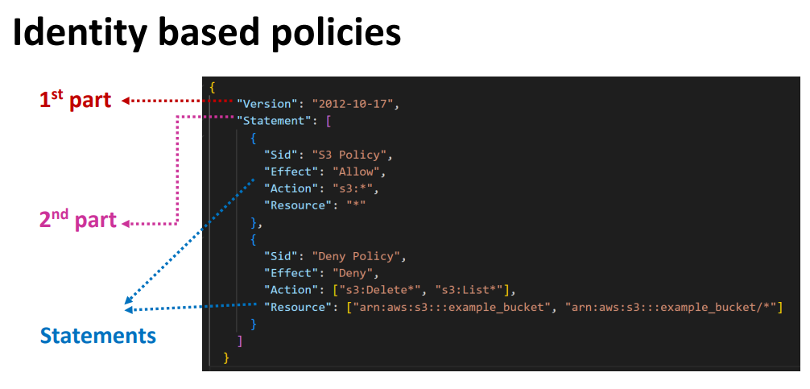

Link:https://docs.aws.amazon.com/IAM/latest/UserGuide/access_policies.html#policies_id-based

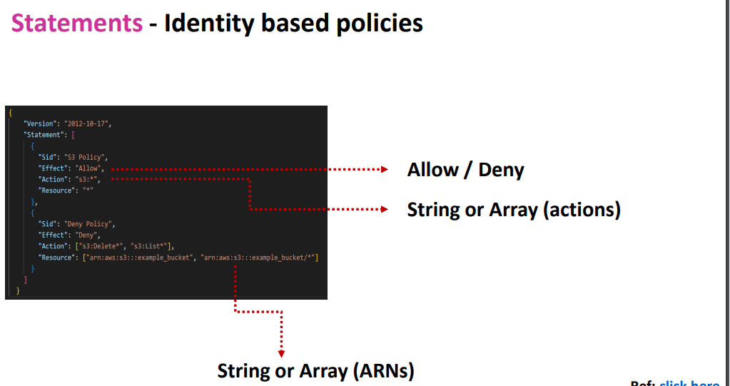

Effect : allow or deny

Action: string or array “*” represents all

CRUDLD(CREATE , READ, UPDATE , DELETE, LIST ,DESCRIBE)

* List is used for s3 bucket list I am users list Describe is used to specify

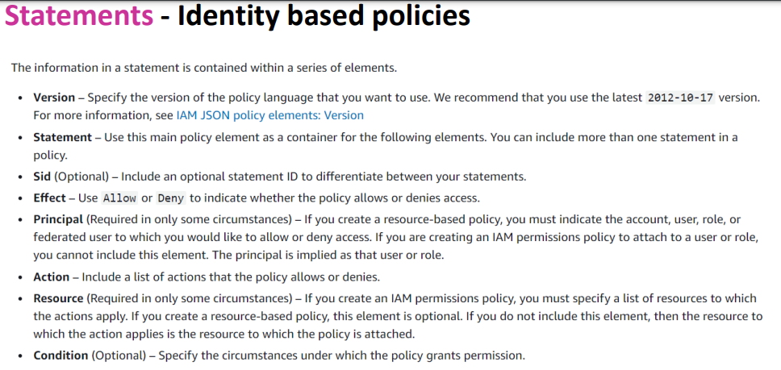

<https://docs.aws.amazon.com/IAM/latest/UserGuide/access_policies.html#policies_id-based>

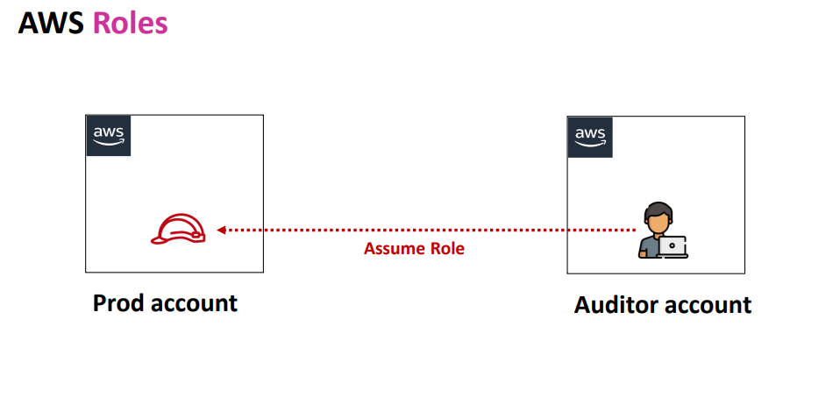

Auditor who has already aws act we only give role permission so that he can directly connect to production act

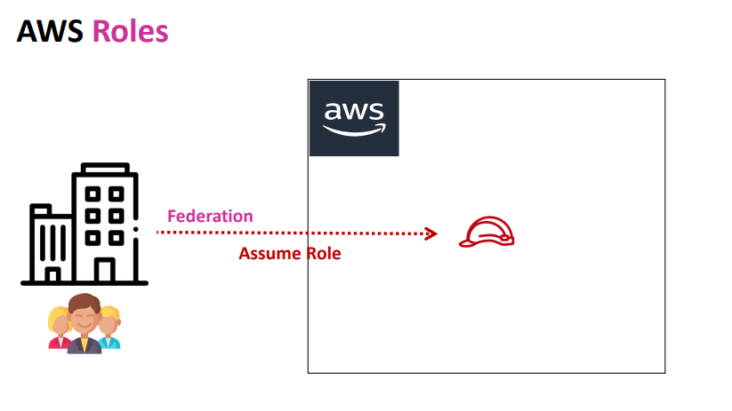

Active directory (Onpremise to aws ) is known as federation using assume role

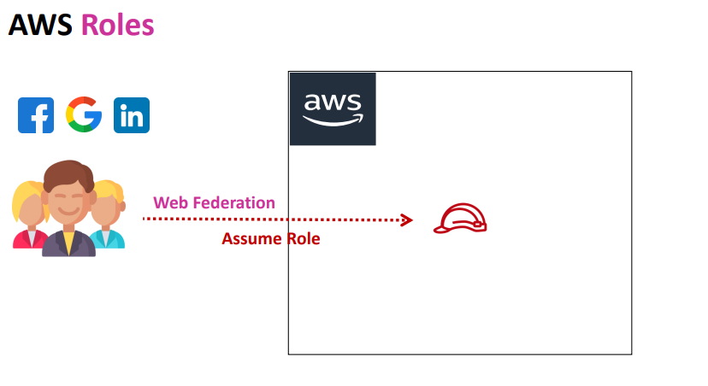

Social media to aws connectivity isknown as web federation with assume role

IAM Policies : demo

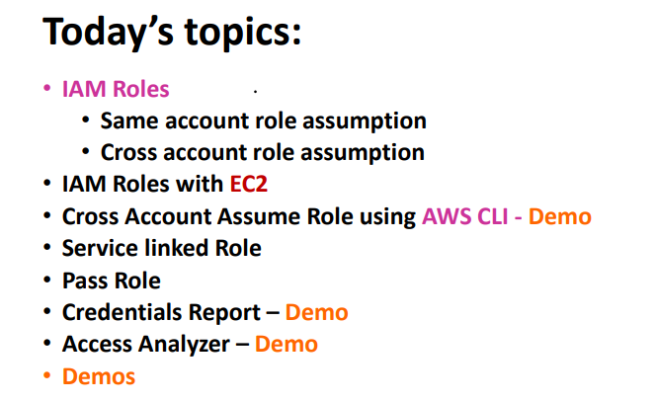

Inline policy is will not be aws managed or else customer managed policy

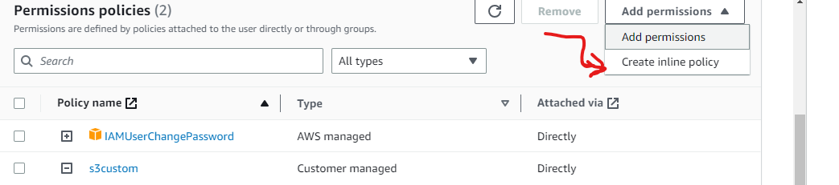

It will be only applicable to only 1 user and when u click on add permissions for that particular user u can able to see option called create inline policy

* In policy section you cant be able to see inline policy
* If its aws managed or custom policy it will be applicable for mulyiple users
* Where as inline policy is applicable only to the user which u r creating
* We will using aws managed or custom policies if we want to apply for groups & users
* Inline policy is to apply for specific user
* But performance will be same for inline and aws managed policies

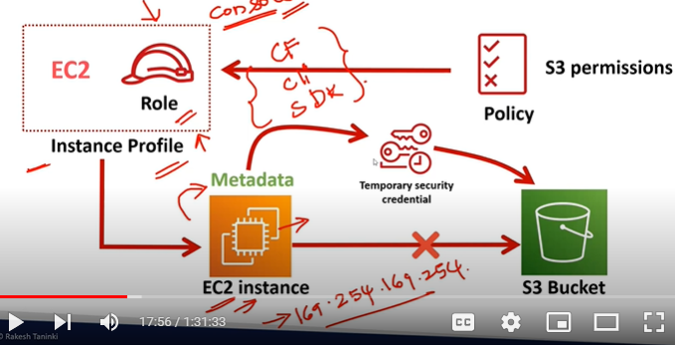

If you want to connect to s3 from Ec2 first u need to create Iam user then using those access keys you can connect to s3 bucket

* But as per best practctice you should not use access keys and secret keys all the time
* Instead of that you can create Iam role for EC2 if you can directly connect instance to I am role you need to have instance profile for that
* But when you create I am role using console aws will automatically create instance profile
* But when you create roles using cli,Cloud formation ,terraform it wont create instance profile automatically u need to create separately role and along with instance profile
* From Iam role you can get credentials for ec2 to get connected with s3
* First you will be creating Iam role by adding s3 permissions to it by instance profile you can connect
* Then that s3 permission will attach to iam role
* The ec2 gets temporary credentials from metadata
* Imp EC2 meta data will be stored in o

169.254.169.254 ip windows server or linux server what ever server it might be the metadata will only get stored in 169.254.169.254

* Meta data is nothing but details of server for ex: instance name , which vpc its running on and on which subnet its in
* For EC2 metadata we need to reach 169.254.169.254

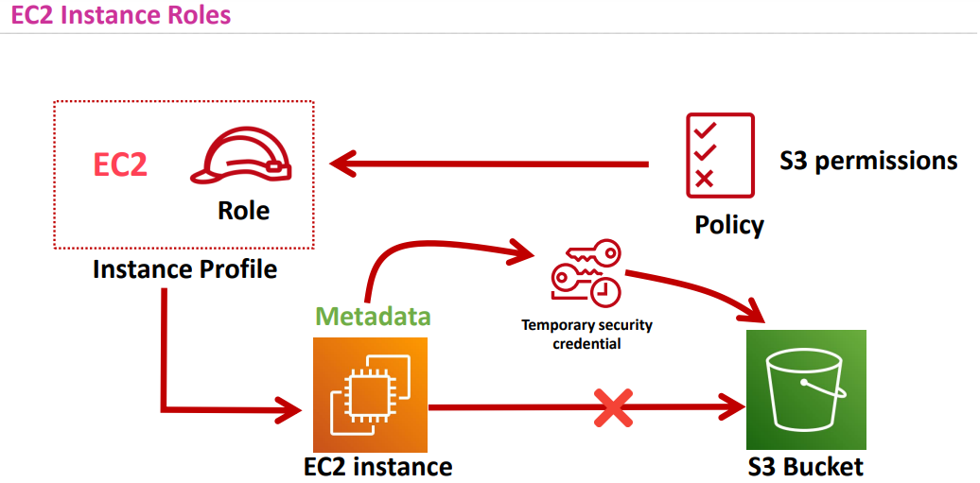

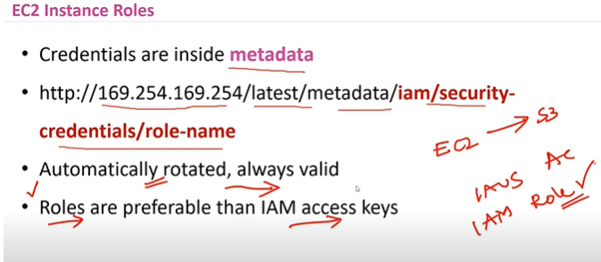

* Roles has high priority than access keys if you have in exam like if you want to connect EC2-> s3 which option you choose
* Options are

1. I am access keys
2. Iam roles (choose ans as Iam role)

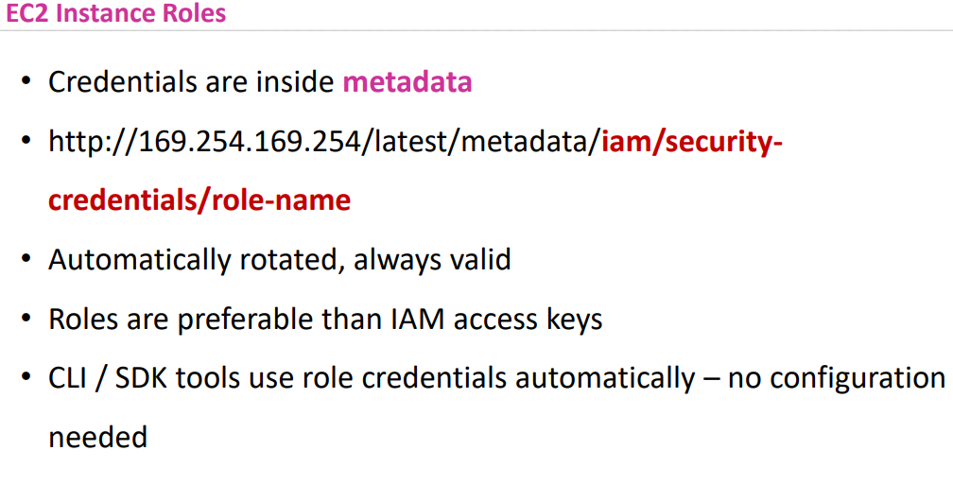

* Credentials can configure in different ways

1. Credentials.aws
2. Environment variables
3. Roles

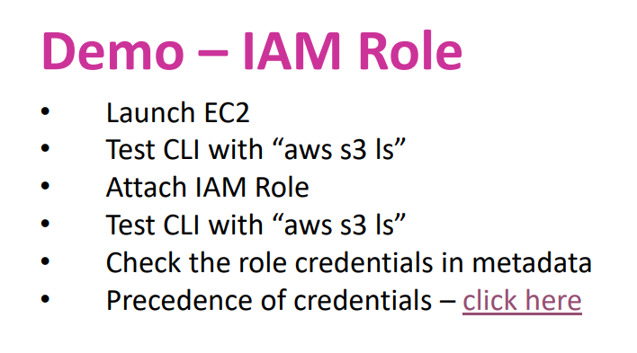

Link:https://docs.aws.amazon.com/cli/latest/userguide/cli-chap-configure.html#cli-configure-quickstart-precedence

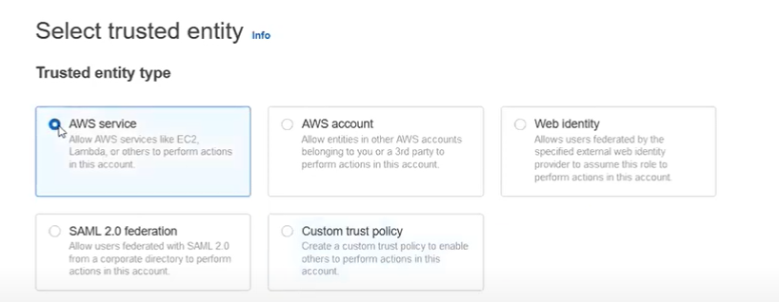

In Iam roles you have different options

1. AWS service- for connectivity between services inside aws
2. Aws account – for connectiving between different accounts
3. Web identity- connectors from social media to aws act ex: google ,fb etc
4. Saml 2.0 federation – Active directory (on premise to aws act
5. Custom trust policy- Iam from anywhere you can create

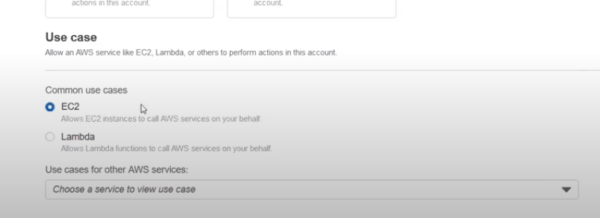

For which service u want to create role

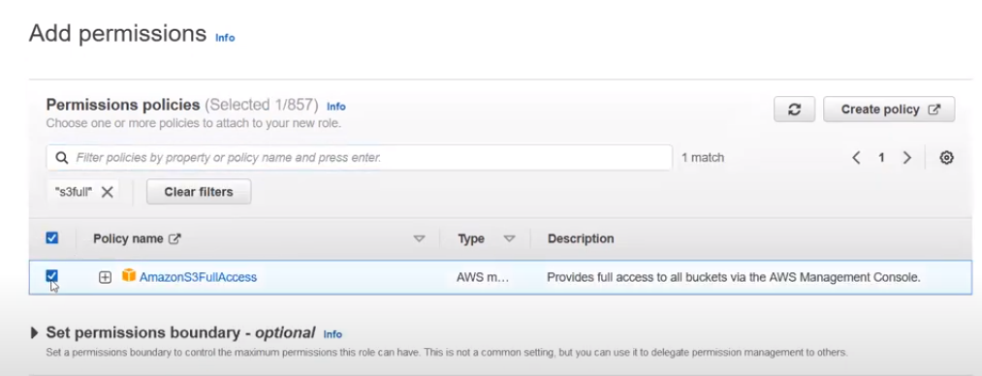

Role name-> create role

* As soon as you create role instance profile for ec2 also gets created

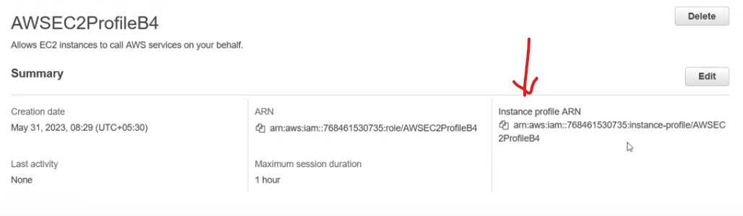

Profile arn is only for ec2 instance

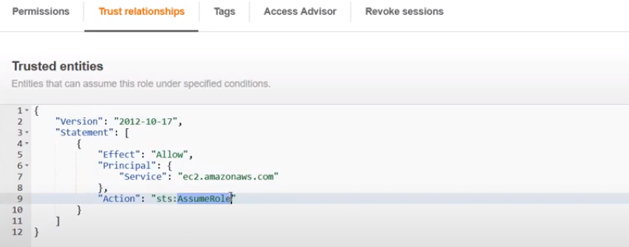

In service its ec2.amazon.com it’s a url for that particular service

Action: sts .assumerole( simple token service)

If we have this then only we can generate temporary credentials

Maximum session duration of role is 1hr to 12 hrs

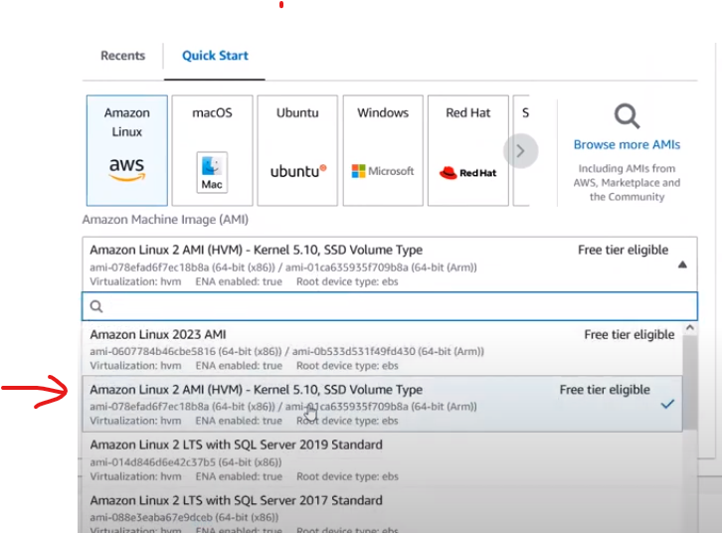

Create ec2 instance with this os

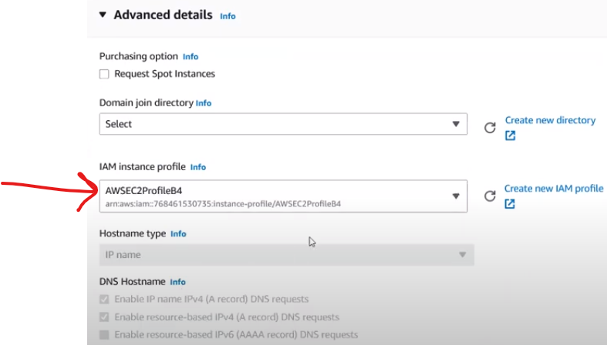

In advance options while create ec2 you will get option like iam instance profile which u have created

* Then click-> launch instance

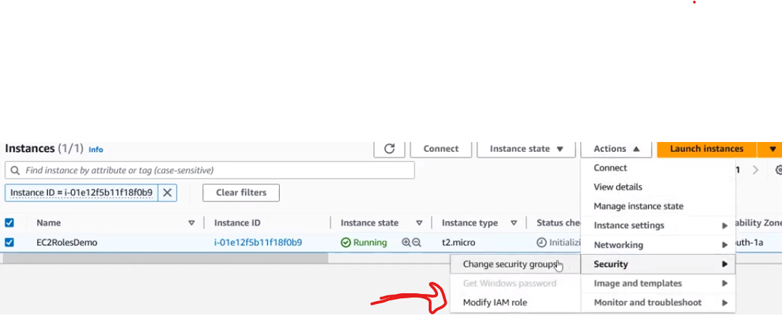

If you forgot to add iam role in ec2 you can later attach like shown in picture



From connect try to connect the server type the following command aws s3 ls

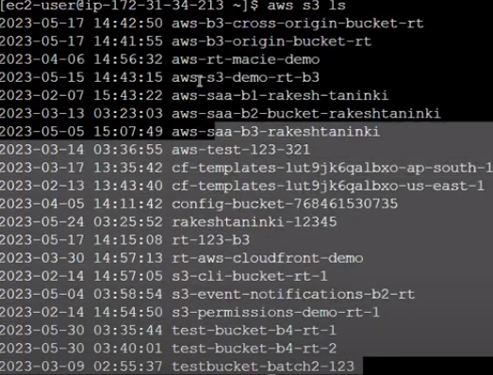

You will get bucket list like this



If you want check bucket files aws s3 ls s3:// bucket name

Automatically credentials got configured



If you type aws iam list users command it throws error as from ec2 you have only permissions for s3



For metadata

For metadata latest version type latest at the end of the command

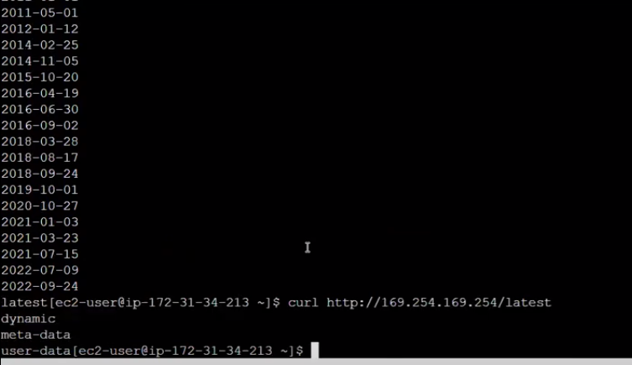

For extra details inside metadata if you want to check run these commands



For which role has been attached if you want info regarding that type below commands

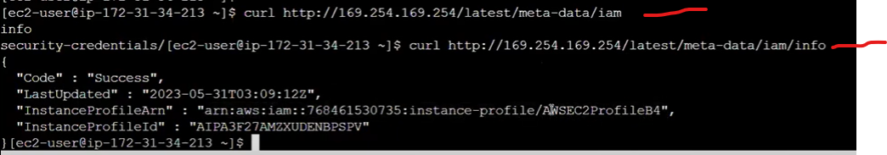

* Delete the instance after completeion of task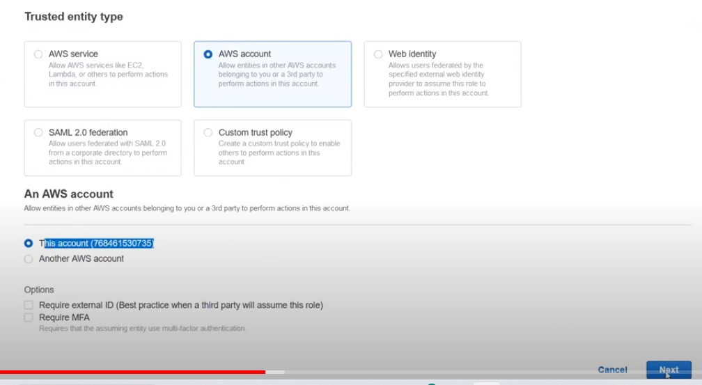
* Now demo is for roles – aws account

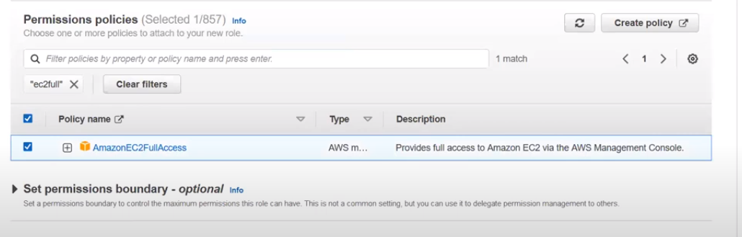

For same act in principal it shows ur own act id

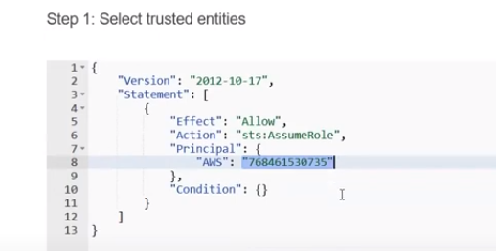

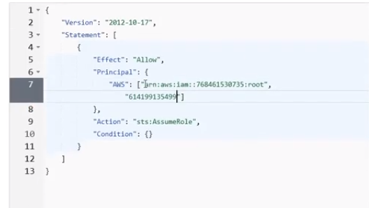

For another act you can add act id by creating array in principal section

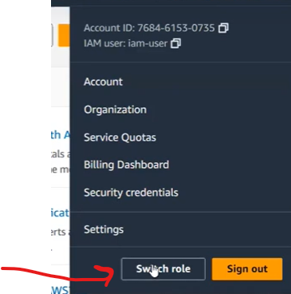

Switch role options will be there in only aws iam users act not In root act

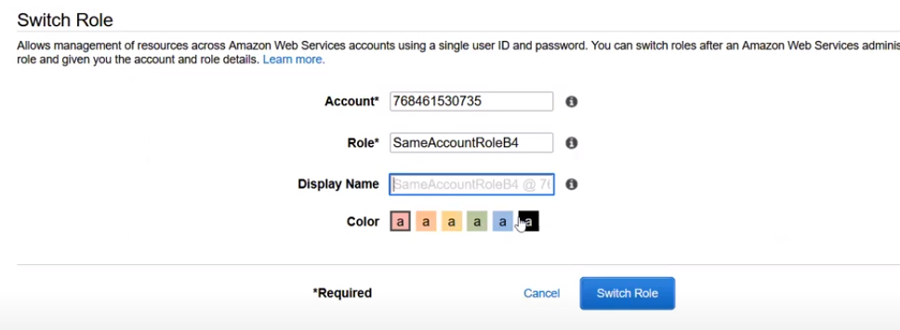

In switch role you can switch to your own act with role which you have created

.in switch role from the user which you have created the switch should have role permissions if not you cant switch to that role

* Switching the role u need to connect with account no and role name

Create inline policy for that particular iam user so that role gets assumed

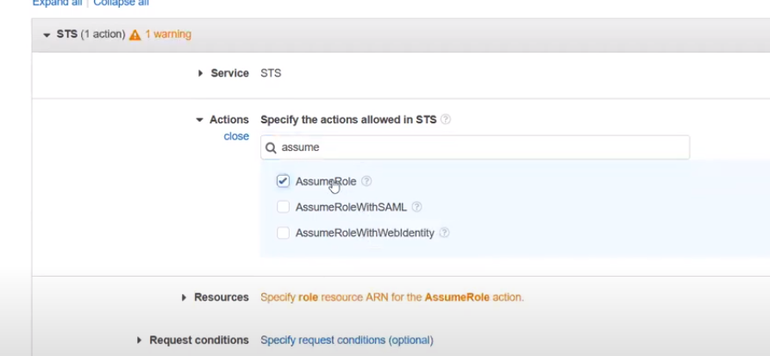

Iam role for cross act

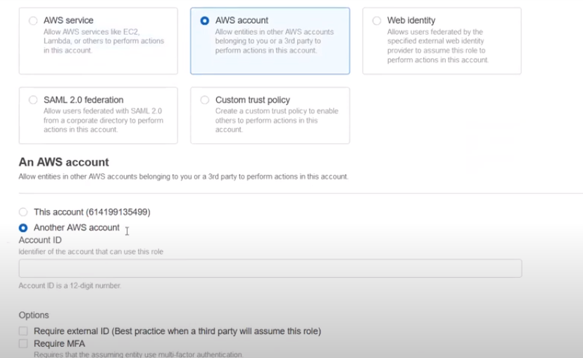

Create iam role for another act

In real time scenarios if ur organization has 10 acts u only create 1 user and give all 9 act iam roles permission to switch from one act to another act

* For Cli create iam user – with access keys

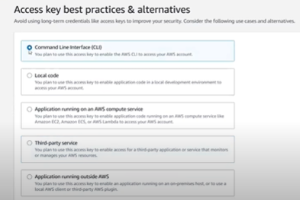

After creating access keys open cmd

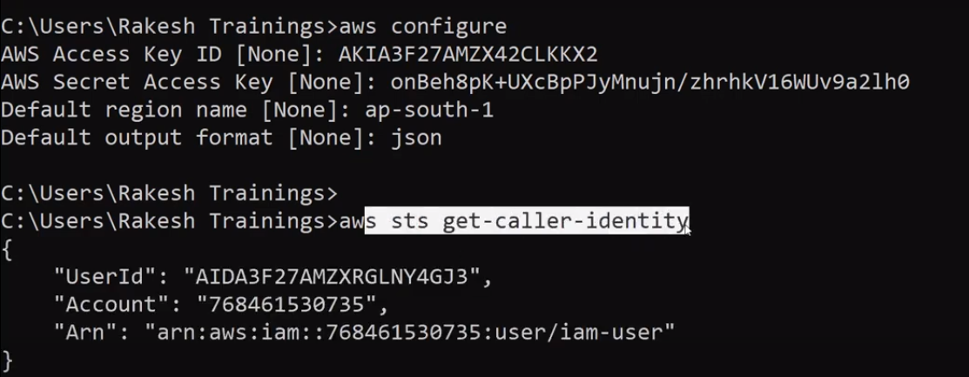

Aws configure & AWS sts get-caller-identity will give u act info from which act u logged in

commands

Cd .aws

Notepad credentials

For switch role cd..

Temporary credentials

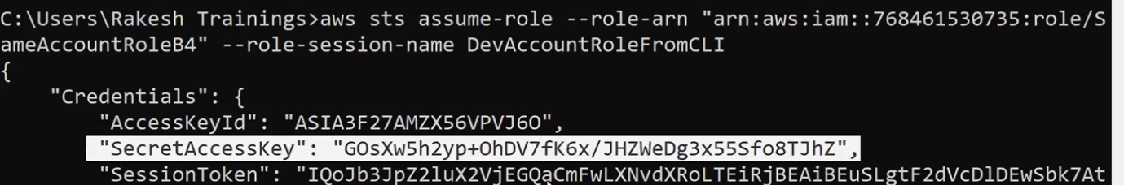

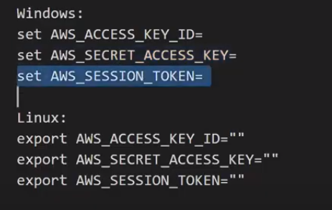

For automation

Cd .aws

Dir

Notepad credentials

Notepad config

In config file add profile assume role

Iam roles using cli

* As iam roles need user to switch act first we need to create user and need to create access keys for that particular user
* For configuration of aws need to open cmd and type aws configure command
* Then give access keys and secret keys to it
* 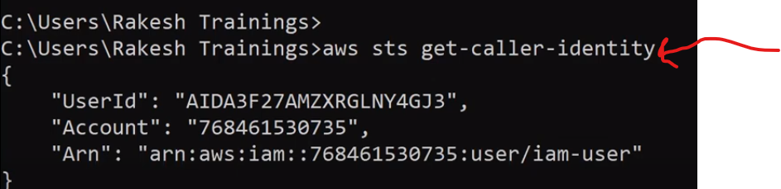

Aws sts get-caller-identity - to know your login identity (which user u logged into)

Cd .aws

Notepad credentials

Giving user assume role permissions for that particular user command

aws sts assume-role --role-arn "arn:aws:iam::123456789012:role/example-role" --role-session-name AWSCLI-Session ->session name

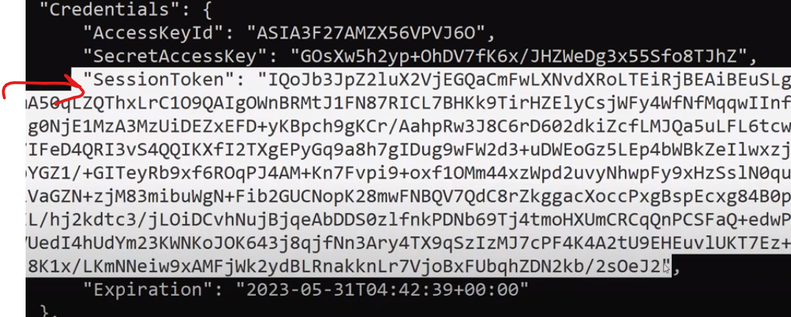

For every session token gets generated for temporary pupose and u will also get expiration details

* Directly u cannot switch as its cli so for confirmation again type command aws sts get-caller-identity
* For switching u need to configure it in environment variables in another command prompt
* If u configure aws configure again it will over ride the credententials so only for that particular session we are using
* set environment variables
* Windows:
* set AWS_ACCESS_KEY_ID=
* set AWS_SECRET_ACCESS_KEY=
* set AWS_SESSION_TOKEN=

linux:

export AWS_ACCESS_KEY_ID=""

export AWS_SECRET_ACCESS_KEY=""

export AWS_SESSION_TOKEN=""

* what ever u configure in environment variables it has more priority
* after expiration u need new credentials
* for automation of credentials
* cd .aws
* dir
* notepad config in config file u need to config role

[profile assumerole]

role_arn = arn:aws:iam::768461530735:role/SameAccountRoleB4 (role details)

source_profile = dev-admin-user (user name)

* take another cmd and type aws sts get-caller-identity - - profile assumerole (you will get temporary credentials as you have automated)
* notepad credentials

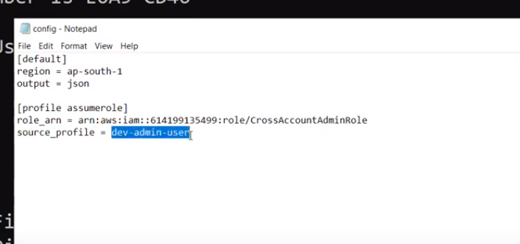

Credential Report ( for ex you have lots of users in your organization so ) so you want to check there credentials for all the users

* you can generate the report it will be in csv format
* you can see all the details in that particular report

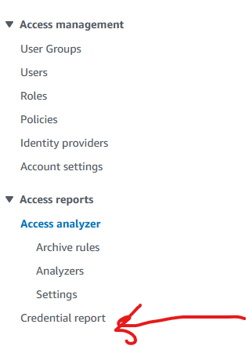

**Access analyzer**: it analyses the security issues of iam and s3

For example s3 bucket shoulnot be public if our s3 bucket is in public it shows it in access analyzer

* in Iam if we give access to another act then also it shows that info in access analyzer
* for the first time if your are creating access analyser it needs 30 to 40 mins for findings
* and you can resolve the issues by clicking archive if you intendly done if not you need to remove the access and next need to rescan
* security hub service is also for security findings
* Service linked roles: In aws we don’t have direct access to connect from one service to another service for that purpose we are creating roles in that
* Aws automitally creates service linked roles when you activate that service for ex: if you activate
* 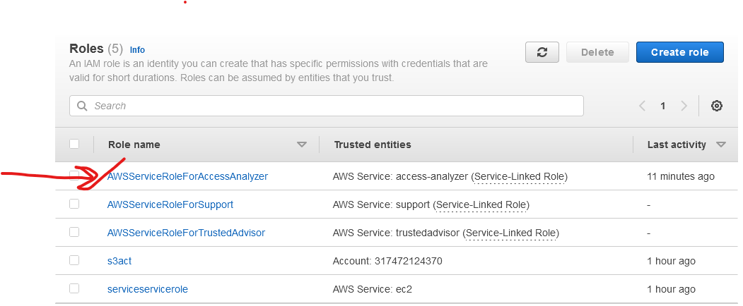
* As soon as you activate access analyzer aws creates service linked role naming AWSserviceroleforAccessAnalyzer
* Pass Role : if you are creating an Iam role for particular service you need to have passrole permission to acttach that role to service if not role doesn’t wrk on that service

Assume role”: Assume role is for temporary credentials pass role is for attaching roles to service

